

The Lighthouse
Zion & Trinity Lutheran Churches
950 Huron
St. Ignace, MI 49781

Address Service Requested

Nonprofit Org.
U.S. Postage
PAID
St. Ignace, MI 49781
Permit No. 55

THE LIGHTHOUSE

Newsletter for November 2013

In him was life, and that life was the light of men. John 1:4

Message from Our Pastor

A nice big moist turkey surrounded by heaping piles of stuffing, mashed potatoes, gravy, beans, carrots, corn, and don’t forget the cranberry sauce. Oh, what’s that coming out of the kitchen? Pumpkin Pie! I think I can find a place for that. Are you hungry yet? That is my memory of Thanksgiving. Sitting down to a table full of delicious food, which I always ate too much of. It is funny when you stop and think about it, just how much of our holiday memories revolve around food. Whether it be Thanksgiving, or Christmas, or Easter, or even Forth of July and New Years, I have all these memories of the amazing food we would have at each. I am sure many of you have those same memories. There is just something about food, about sitting down together for a big meal that sticks with us. And I don’t mean in the hips.

There is a lot of power in having a meal together. It forms relationships and creates memories. In fact the Bible itself is full of stories of people sitting down and having a meal together. In the Old Testament whenever a visitor showed up what was the fist thing that happened? Preparations for a great dinner began. In Jesus own ministry so many of the settings for Jesus interactions with others take place around a meal. That is what Jesus got in trouble for more than anything else, sitting down and eating with sinners. Jesus’s last interaction with his disciples takes place at a meal, where they enjoy their last supper together. Even when Jesus comes back from the dead and reveals himself to the two men on the road to Emmaus, it wasn’t till they sat down together to eat that they saw who Jesus was. There are so many stories throughout out Bibles about just how powerful and meaningful sitting down for a meal together is.

So who do you sit down to eat with? Who do you enjoy a meal with? One of the things I really love about our worship service is that we incorporate a meal in it. Now I have to admit, Communion isn’t much of a meal. But we are still gathering together to eat and drink with one another. To taste the meal set before us at Christ’s table. And it doesn’t matter who you are, you are welcome at that table. People of all races and nationalities. People from every stage of life. The rich, the poor, the healthy, the sick, the well, and the hurting can all join together in this meal. It is a truly beautiful thing as we all come to eat and drink Christ’s body and blood and the forgiveness that it brings. So join us some Sunday and let’s have a meal together. Come and see just how powerful it can be.

All Saint’s Day

November 1st is All Saint’s Day. This is a day in the church when we remember all the baptized who’ve gone before us. In the past year, we have buried the following saints:
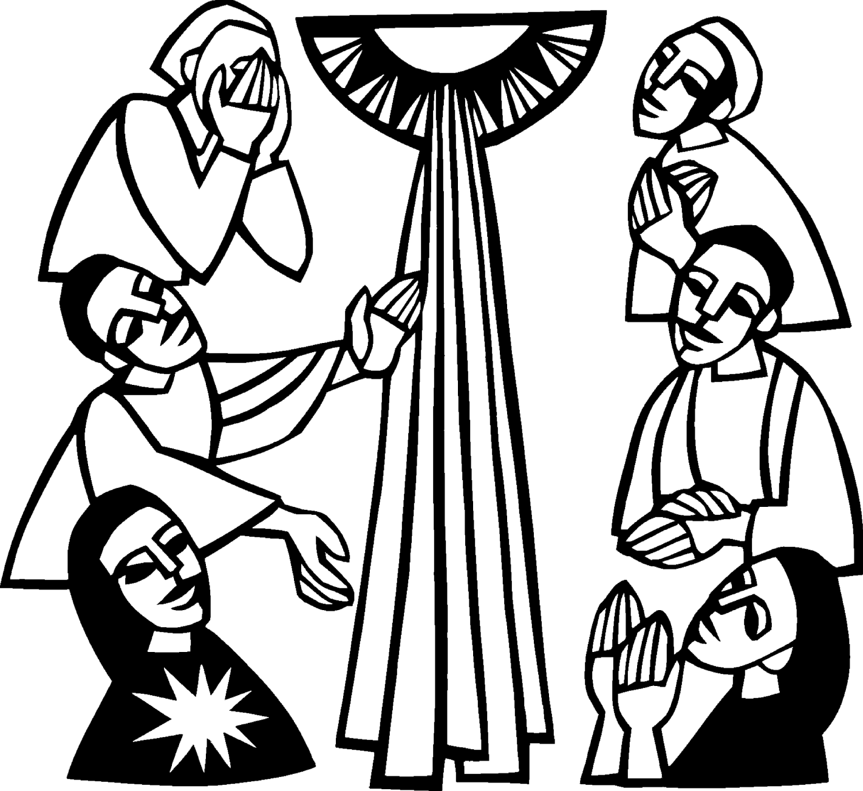

Edythe Ritter
&
Ken Baskin

Newsletter

The November Newsletter was not adopted. ☹

Noisy Offering

The noisy offering for November 3rd will go to the Food Pantry

Lutheran Men in Mission

Lutheran Men in Mission will be at Pastor Jeremy’s house on Sunday, November 10th at 7:00 pm. Join us for fellowship, food, Bible Study, and of course some Sunday Night Football.

NOIZ

Sunday, November 17th at 7 – 9 pm, all High School Youth are invited to come to church as we gather together for food, games, and conversation

GiG

Growing in God continues in November. All children from K-5 are invited to come join us from 3:30 to 5:00 pm. Helpers are still needed. GiG meets on Wednesdays except for the last Wednesday of the month.

Confirmation

Confirmation will be the first two Wednesdays of the month at 7 pm.

Choir

Choir practice is usually on Thursdays at 7 pm at the United Methodist Church.

Trinity Bible Study

Bible Study on will continue at Trinity on Fridays at 1 pm.

Community Thanksgiving Service

The Community Thanksgiving Service will be November 24th at 7:00 pm at the United Methodist Church.

Communion Class

We will be having a communion class on Saturday, November 9th at 10:00 am. This will be a class targeted at children as they learn of the wonderful gift that is Christ’s body and blood. If your kids are currently taking communion, or if they would like to, I encourage you to come and explore the wonders of Holy Communion.

New Member’s Class


There will be a new member’s class for all
who are interested in joining Zion or Trinity.
This will be on Tuesday, November 12th
at 7:00 pm upstairs at Zion.
We will learn some basics of
Lutheranism and what it means
to be a church member.

Church Decorating

On November 24th at noon we will gather together to decorate the church in preparation for Advent and Christmas.

Service Sunday - Thanks

A big thank you to all those who have helped on the service Sunday projects we have done so far. We have truly been doing God’s work with our hands in the community. If you have not come and helped yet, I encourage you to give it a try.

Service Sundays are all about family; our own individual families, our church family, and our human family. It is an opportunity for us to be active with our faith, finding ways to live out what we truly believe. When we take church out of the building everyone wins.

On November 24th we will be delivering all the food collected during our November food drive to the food pantry.

Notes

If you haven’t picked up your church directory, stop by and grab one. Third quarter contribution statements are in the back of the church.

Personal Invitations

A personal invitation is a powerful thing. It shows you are thinking of that person. That you care for them. That you want them to be included. It feels good to get invited to a party or any event. And yet how often do we apply that same thinking towards inviting others to church. Studies have shown that the most effective way to evangelize and grow a church is to simply invite people to come. A real personal invitation from one person to another. According to data from the book The Inviting Church, church visitors came from the following reasons;

2% by Advertisement
6% by the Pastoral Invitation
6% by organized evangelism campaign
86% by invitation from friends or relatives

86%, that is huge number. That is you out in the community inviting others to be a part of what we are. So I challenge you to be out there inviting others to church. It really is not that hard, all it takes is a simple question. Would you like to come to church on Sunday? We don’t need to question why they don’t go. We don’t need to try and guilt them into coming. We don’t need to come up with some grand scheme to convince them to come. It doesn’t matter if they have never been in church or have just not been for a little while. All it takes is an initiation. So invite someone, give it a try, and maybe they just might come.
Movie and Book Recomendations

Book – Pastrix: The Cranky, Beautiful Faith of a Sinner & Saint by Nadia Bolz-Weber. Nadia, a Lutheran pastor in Colorado, tells her wonderful story of faith.

Movie – Luther – This 2003 telling of Martin Luther’s story is a great watch around Reformation Day.

Food Drive

November has always been a month during which we give thanks. So this November at Zion and Trinity as we remember all that we have been blessed with, and give thanks for it all, let us also remember those who are in need.

Thus I encourage everyone to bring in food for the local food pantry all during November. We will collect it all month, then bless it before giving it to the pantry to support those who need it most.

Monetary gifts will also be accepted during this time and always, as the pantry has an ever growing grocery bill to feed the hungry in our community.

Baptismal Anniversaries

November 2 Joshua LaJoice

November 12 Misti Gamble
November 13 Tim Idalski
November 14 Adrian Coleman
November 14 Madison Coleman
November 17 Kristen Olsen
November 21 Duane Gamble
November 25 LaRoy Hill
November 27 Mike Wilkins
November 27 Mandy Fenlon

Birthdays in November

November 3 Tim Idalski
4 Ernie Vallier
4 Linda Wilkins
7 Rita LaVake
11 Kathy Marshall
11 Samantha Wyers
12 Shirley Winberg
15 Nancy Hardy
15 Alicia LaLonde
17 Faith Gaubault
17 Wyatt Huhn
17 Kyra Spencer
18 Lori Bowlby
19 Connie Olsen
19 Justin Stenson
22 Lisa Gamble
23 Shirley Campbell
25 Dawn Akers
26 Misti Gamble
28 Gloria Marshall
29 Jesse Rogers
30 Virginia Hopper

Anniversaries in November

November10 Judy & Don Massey
Servants for Zion

Ushers & Greeters

Nov 3 Nicole Garen Family
Nov 10 Sam LaVake Family
Nov 17 Confirmation Youth
Nov 24 Amy Dodds Family

Lectors

Nov 3 Dawn Akers
Nov 10 Linda Wilkins
Nov 17 Rita LaVake
Nov 24 Andrew Sjogren

Acolytes

Nov 3 Joel Dodds
Nov 10 Casey Brake
Nov 17 Emma Feleppa
Nov 24 Donovan Insley

Communion Assistants

Nov 3 Tim Idalski
Nov 10 Jerry Fenlon
Nov 17 Faith Gaubault
Nov 24 Fred Feleppa

Altar: Karen Schlehuber
Money Counters: Dena Barker & Carol Elmblad

On November 17th, we will be providing the service at the Long Term Care Facility. Please help out if you can.

Zion Funeral Committee August - November

Team Leader: Linda Wilkins (643-7710)
Co-leader: Rita LaVake (298-0005)

Trinity Worship Families

Nov 3 Rose Family
Nov 10 Baron Family
Nov 17 Gustafson Family
Nov 24 Chalmers Family

Prayer List

Bonnie Bergeron, Ann Dyer, Jim Dyer, Carl Belonga, Mary Belonga, Ruth Cope, Dan Pope, LaTaunya Paquin, Christine Movalson Shaw, Silas Robert, Phil Richel, Nadine Dandona, Jackie Kallstrom, Pat Bell, Mary Streeter, Amy Kinjorski, Janice Werkheiser, Joy Olsen Marolf, Larry Leveille, Karen Schlehuber, Chris Barker, Brenda St. Onge, Kristine McDonald, Barbara Nelson, Linda Cheeseman, Don Massey, LuAnne Keinonen, Larry Peters, Tom Alkire, John Lucas, Judy Childs and Celeste.

That’s a Joke, Son

Q: How many Lutherans does it take to screw in a light bulb?
A: I don't know, but if it's in the front row, it will never get fixed!
–Ross
Appleton, Wisconsin

Council Meetings

Trinity Council Meeting – 6 pm, November 18th
Zion Council Meeting – 6:30 pm, November 20th

Zion’s Council Members

Treasurer: Dawn Akers 643-7552
Jerry Fenlon 643-8730
Susan Fenlon 643-8730
Faith Gaubault 298-1800
Paul Shepard 984-2069
Tim Idalski 643-6574
Fred Feleppa 643-6793
Lorraine Graham 643-8419

Trinity’s Council Members

President: Jerri Rose 292-5570
Vice-President Tracy Movalson 292-5581
Secretary: Sharon Chalmers 292-5440
Treasurer: Pega Kennedy 292-5633
Co-Treasurer: Jim Rose 292-5570
Financial Secretary: Joe Chalmers 292-5433
WELCA: Pega Kennedy 292-5633
John Kennedy 292-5633
Jim Dyer 292-5433
Lois Movalson 292-5581

Treasurer's Report for Zion
January 1, 2013 through October 12, 2013
Income:
 | Building | $3,700.00
 | Church Use Income | $0.00
 | General | $60,114.32
 | Thrivent Financial | $473.00
 | Trinity Share | $10,550.00
 | TOTAL |  | $74,837.32
Expenses:
 | Administration | $4,245.76
 | Benevolence | $5,218.23
 | Church Maintenance | $12,319.42
 | Education | $758.50
 | Parsonage Maintenance | $1,957.85
 | Pastoral | $38,361.33
 | Worship | $3,330.35
 | --To Building Fund | $7,925.51
 |  |  | $74,116.95
Balance: |  |  | $ 720.37
***********************************************************
9/12/2013
General fund owes Building fund: |  |  | $ 7,630.00
General fund owes Mission Endowment fund: |  |  | $ 9,995.00
General Fund balance: |  |  | $ 201.28
Building Fund balance: |  |  | $ 15,138.66
Thrivent Investment Management Fund: |  |  | $ 299.87
WELCA Kitchen Fund: |  |  | $ 9,160.39
2011 -2013 Capital Campaign Donations |  |  | $ 20,069.00
Zion Lutheran Council Meeting
October 16, 2013
Present: Pastor Jeremy, Jerry Fenlon, Susan Fenlon, Lorraine Graham, Tim Idalski and Paul Shepard

Meeting opened with Pastor leading us in devotions and a prayer at 6:36 p.m. Vice-President Jerry Fenlon presided.

The Secretary Report was approved as presented.

Pastor’s Report:

The youth groups are all off and running. There is a good group for NOIZ. There are about 10 confirmands. GiG is starting slow but should pick up as we go along (as usual).

“Breaking the Mold” was held at Zion. Attendance was disappointing. A group from St. Ignace and a group from the Sault were the only ones to attend. Those who attended thought it was worth the effort to come. There will be another meeting in November to plan youth activities.

We will be handing out Bible to third graders on October 27th (Reformation Sunday)

Service Sunday for October 27th will be at Legacy House. It was suggested we also have a group making bars and other snacks for the Hope Annual Meeting which is being held on October 28th at Zion.

We will be having a Reformation Party for the NOIZ group and the confirmands at 5 pm on October 27th.

In November we will be starting a “new members” class and a communion class for kids.
Our Conference Annual Meeting was held in Cedarville. Officers were elected and finances discussed. Susan mentioned that each of the pews had quilts they had made for Lutheran World Relief. She suggested we start up a group to make quilts as we haven’t had one for many years. It was suggested we might ask the Endowment Fund to purchase supplies for the quilts.

The Treasurer’s Report was approved as presented.

Old Business:

The pastor has contacted Ben Idalski regarding the building of our new website.

The copier has been purchased. The average time for printing the newsletter has been reduced from five hours to two.

Jerry Fenlon is still arranging to power-wash the sides of the church to get rid of spider webs, etc. They have asked Todd Blair to provide equipment.

We need to purchase new boilers soon. We only need a few more thousand to reach our goal.

We will leave the sign-up sheet out for one more week before buying t-shirts with Zion’s name on them. We will purchase them locally and should have them for the next Service Sunday.

We have two new people helping with the altar. We want to thank Mike Herman and Karen Schlehuber for volunteering. Susan will be sending out postcards to see if we can get more volunteers.

New Business:

Thrivent has a program called Simply Giving where parishioners can give their contributions each week automatically from their savings or checking account. We will look into starting this option.

The meeting adjourned with the Lord’s Prayer at 7:31 p.m.

Respectfully submitted,
Lorraine Graham

Trinity Lutheran Church Council Meeting
October 21, 2013

Those present were John and Pega Kennedy, Tom and Joyce Gustafson, Sharon Smith, Jim and Jerri Rose, Joe and Sharon Chalmers, Tracey Movalson, and Pastor Jeremy.

The meeting was opened with Pastor Jeremy reading an excerpt from the book Provocations by Thorn Kierregaard.

Secretary's Report: Read and Approved with the exception of correcting the date for the Hope Chest meeting.

Treasurer's Report: Read and Approved

OLD BUSINESS

Stained Glass - They will call Tom when they are in our area.

Table Cloths - Pega will check with Freddy Paquin about where he got the table cloths in the Truck Stop.

Paraments - Pastor will check out what paraments we will need and he found a web site for replacing our board numbers.

More Funds to Spend - Benevolent Committee will meet to discuss where to make expenditures.

NEW BUSINESS

Trees and Bushes - Tom suggested we ask Dan from Sunshine Nursery to trim and/or pull bushes at the church entrance.

Pastor asked if we were interested in paying our offering on-line. The consensus was "no" because we can't always get on-line out here.

The meeting was adjourned with the Lord's Prayer

Respectfully Submitted,
Sharon Chalmers

Contact Information

Pastor Jeremy Winter may be reached at 906-643-0391 or at jwinter001@gmail.com or in case of emergencies,
Pastor’s cell phone number is 712-389-2747

Church telephone: 906-643-7870 - Answering machine
The secretary is in the office on Tuesdays & Thursdays.

The email address for the church is: ziontrinity950@yahoo.com
The website is at www.lutheransonline.com

ELCA Global Links


Gods Work. Our Hands.

Stay Informed
Be Inspired
Get Involved

Malaysia: Church celebrates anniversary, reaches out to neighbors
Birthed from missionary efforts of the United Lutheran Church in America, this year marks the 60th anniversary of the establishment of the Lutheran Church in Malaysia. Now this church engages in outreach within Malaysia and in neighboring Myanmar, Vietnam and China. See www.ELCA.org/Malaysia-anniversary.
Syria: Refugee aid goes beyond material needs
Personal safety is a concern for many of the approximately 125,000 Syrians in the Za’atri refugee camp in Jordan. Besides material aid, your donations to Lutheran Disaster Response address this concern by helping to raise awareness about such threats as gender-based violence. See www.ELCA.org/Syria-programs.

Liberia: Anguish after the death of a child
“Everybody cried, absolutely everybody,” is how the Rev. Brian and Christine Palmer, ELCA missionaries in Liberia, describe the hundreds of mourners after the death of a child from malaria. See www.ELCA.org/Liberia-death.

Calendar Notes

Daylight Savings Time changes on November 3rd. Turn your clocks back.

Smoke detector batteries should be replaced at least once a year. People often change them when the clocks change.

Election Day is November 5th. Your vote counts! ☑


Veteran’s Day is November 11th. 

November 28th - Happy Thanksgiving!

Thanksgiving
For each new morning with its light,
For rest and shelter of the night,
For health and food,
For love and friends,
For everything Thy goodness sends.
- Ralph Waldo Emerson (1803-1882)

